相关资料

colab演示: https://colab.research.google.com/drive/11z58bl3meSzo6kFqkahMa35G5jmh2Wgt

项目网址: https://shunsukesaito.github.io/PIFuHD/

克隆 PIFuHD 仓库
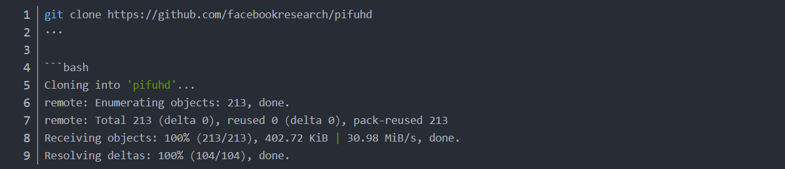

3. 设置输入的图片参数
进入到sample_images文件夹下。一般输入的图像在这个文件夹中

此处，filename 修改成你要生成的图像的名字，并放在/content/pifuhd/sample_images/文件夹下面
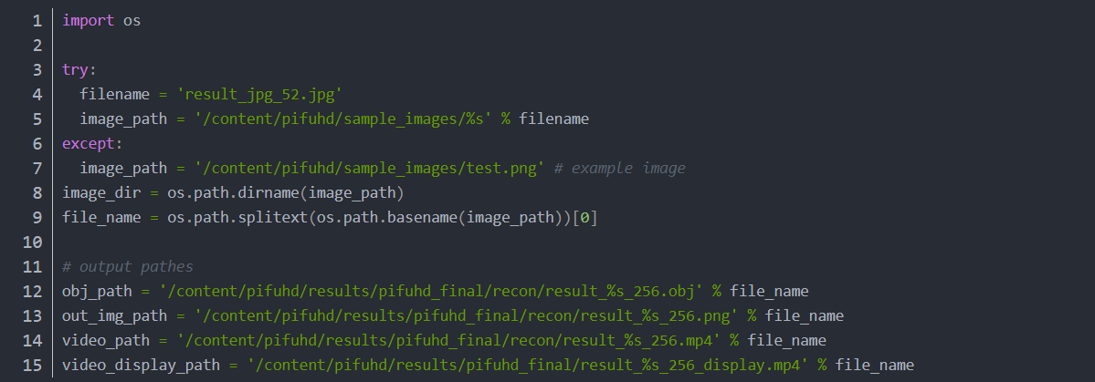
回退到 content 目录下：

4. 用于裁剪图像的预处理
git 下载 lightweight-human-pose-estimation 的源代码
下载成功控制台信息
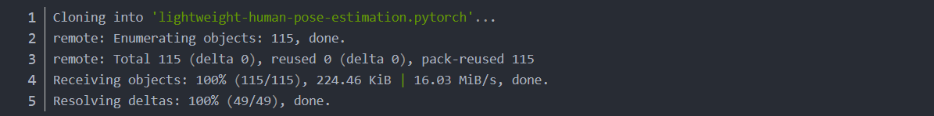
进入到 pytorch 目录文件下
下载已经得到的CheckPoints
!wget https://download.01.org/opencv/openvino_training_extensions/models/human_pose_estimation/checkpoint_iter_370000.pth
定义得到 get_rect 函数
import torch
import cv2
import numpy as np
from models.with_mobilenet import PoseEstimationWithMobileNet
from modules.keypoints import extract_keypoints, group_keypoints
from modules.load_state import load_state
from modules.pose import Pose, track_poses
import demo

def get_rect(net, images, height_size):
net = net.eval()

stride = 8
upsample_ratio = 4
num_keypoints = Pose.num_kpts
previous_poses = []
delay = 33
for image in images:
rect_path = image.replace('.%s' % (image.split('.')[-1]), '_rect.txt')
img = cv2.imread(image, cv2.IMREAD_COLOR)
orig_img = img.copy()
orig_img = img.copy()
heatmaps, pafs, scale, pad = demo.infer_fast(net, img, height_size, stride, upsample_ratio, cpu=False)

total_keypoints_num = 0
all_keypoints_by_type = []
for kpt_idx in range(num_keypoints): # 19th for bg
total_keypoints_num += extract_keypoints(heatmaps[:, :, kpt_idx], all_keypoints_by_type, total_keypoints_num)

pose_entries, all_keypoints = group_keypoints(all_keypoints_by_type, pafs)
for kpt_id in range(all_keypoints.shape[0]):
all_keypoints[kpt_id, 0] = (all_keypoints[kpt_id, 0] * stride / upsample_ratio - pad[1]) / scale
all_keypoints[kpt_id, 1] = (all_keypoints[kpt_id, 1] * stride / upsample_ratio - pad[0]) / scale
current_poses = []

rects = []
for n in range(len(pose_entries)):
if len(pose_entries[n]) == 0:
continue
pose_keypoints = np.ones((num_keypoints, 2), dtype=np.int32) * -1
valid_keypoints = []
for kpt_id in range(num_keypoints):
if pose_entries[n][kpt_id] != -1.0: # keypoint was found
pose_keypoints[kpt_id, 0] = int(all_keypoints[int(pose_entries[n][kpt_id]), 0])
pose_keypoints[kpt_id, 1] = int(all_keypoints[int(pose_entries[n][kpt_id]), 1])
valid_keypoints.append([pose_keypoints[kpt_id, 0], pose_keypoints[kpt_id, 1]])
valid_keypoints = np.array(valid_keypoints)

if pose_entries[n][10] != -1.0 or pose_entries[n][13] != -1.0:
pmin = valid_keypoints.min(0)
pmax = valid_keypoints.max(0)

center = (0.5 * (pmax[:2] + pmin[:2])).astype(np.int)
radius = int(0.65 * max(pmax[0]-pmin[0], pmax[1]-pmin[1]))
elif pose_entries[n][10] == -1.0 and pose_entries[n][13] == -1.0 and pose_entries[n][8] != -1.0 and pose_entries[n][11] != -1.0:
# if leg is missing, use pelvis to get cropping
center = (0.5 * (pose_keypoints[8] + pose_keypoints[11])).astype(np.int)
radius = int(1.45*np.sqrt(((center[None,:] - valid_keypoints)**2).sum(1)).max(0))
center[1] += int(0.05*radius)
else:
center = np.array([img.shape[1]//2,img.shape[0]//2])
radius = max(img.shape[1]//2,img.shape[0]//2)

x1 = center[0] - radius
y1 = center[1] - radius

rects.append([x1, y1, 2*radius, 2*radius])

np.savetxt(rect_path, np.array(rects), fmt='%d')
使用姿态估计得到人体信息
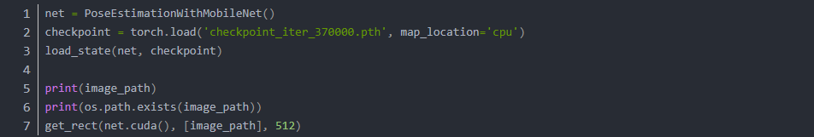

下载预训练模型
控制台打印信息：
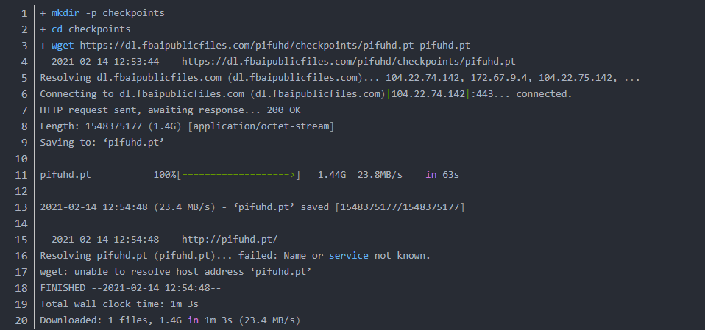

6. 执行 PIFuHD 程序
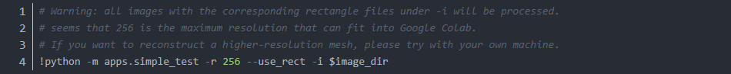
执行的控制台打印信息：
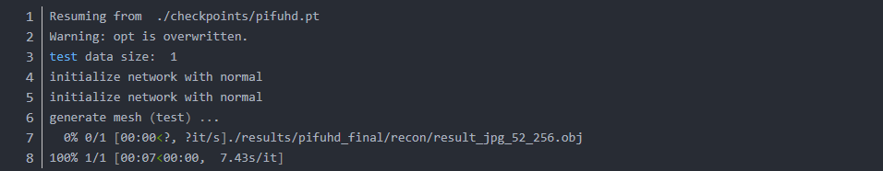
结果保存到./results/pifuhd_final/recon/下面 result_jpg_52_256.obj. 这个obj 文件就可以通过MeshLab或者 blender 打开。

7. 渲染出mesh图像
使用 lib.colab_util 通过 obj 文件生成 video
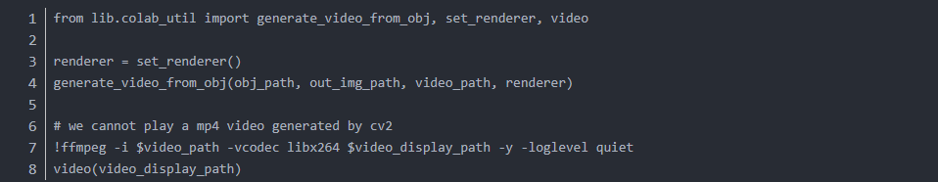

8. 结果图
图片原图，是从网上随便找的一张模特图。如果要图像生成质量好的话，最好不是裙子，背景比较单一的那种。
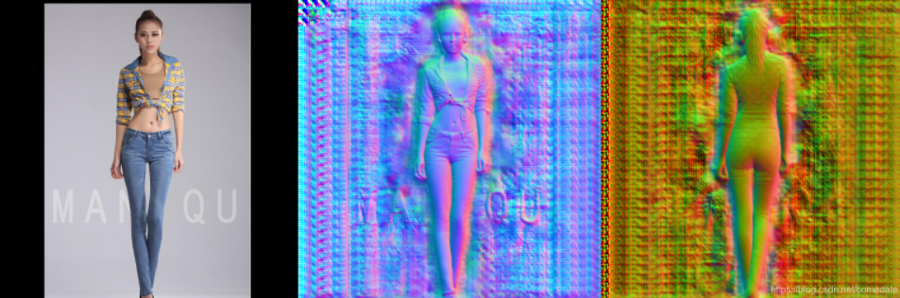
Mesh图：
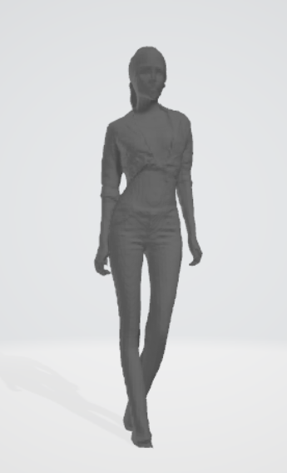
生成的Mesh图，基本上就可以3D打印出来做手办了。

